Montana Coaches Clinic
2017
javelin session

Wade Nelson

Throws coach

Glasgow High School
nelson@mail.Glasgow.k12.mt.us
School: 406-228-8268
Cell: 406-230-1221
Coach Glenn Flatt

1935 – 2017

Malta High School

1959 – 2017

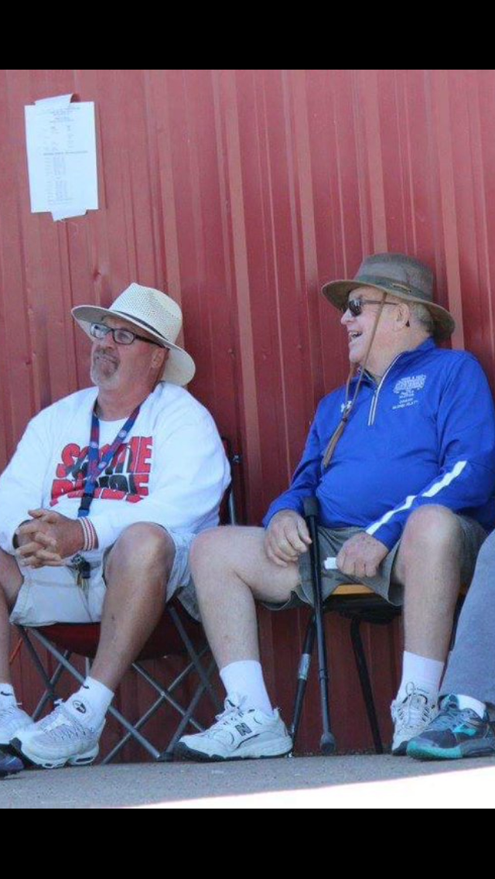

Pride in the program

- Facility

- Moved javelin to infield

- Do it ourselves – coach Moore – get it right

- Regular maintenance – move sector fresh grass

- High standards – expect quality

- Lots of javelins – older for drills – Javelin man

- Athletes

- Issues we face – softball/baseball – live/quick arms

- Javelin throwers come off the track – good athletes

- Coach Phillips – warm up stretches
- Javelin stretches
- Ulnar nerve stretch – rotate and hold
- Don’t over throw – limit hard throws
- No dodgeball tournaments!
- Wednesday is javelin day

- Older athletes mentor younger

- Safety always comes first – eyes on javelin

- Med balls – heavy first two weeks - 2 pound balls

- Two hand overhead
- Two hand with plant
- One hand full extension
- One hand with plant

Tentative weekly throw schedule

MONDAY – starts on grass (without ball or shot/with ball or shot) – ladders (without ball or shot/with ball or shot)

TUESDAY – SHOT DAY - stairs/hills – tires
Goal post shots – grade levels no one fails/don’t be that guy – 10 with no hits

WEDNESDAY – JAVELIN DAY – med balls – throw at cones/lines – javee/bungee – 3 step 5 step full approach

THURSDAY – DISCUS DAY – stairs/hills – bowling pins – tires

FRIDAY – technique touchup/mental focus – little bit of everything not much of anything – pack implements/shoes

The Throw

- STAY LOOSE!

- Visual relaxation loose left hand
- Relaxed and coiled

2. Carry javelin like a waiter carrying a tray of water

- carry drill – down field and back
- level javelin
- control the tip – don’t load up – keep by eye
- Take your right hand to left hand on the throw
- Wrist stays inside elbow
- Low tip - high tail

- Block

- Penultimate step – point at corner of the toe board
- Left side of body stops – energy to right
- Block on front of heel - not toe or heel
- Javelin height comes from block not from release
- Right hip comes thru and up – left foot rotates
- Don’t open block foot too soon – left side caves

- Approach
- Start slow gradually work up
- 3 step – 5 step – 7 step
- Full - 5 jog, 5 run, 5 sprint, cross, plant
- Keep acceleration rate up-give up room-slow to fast
- Visualize running and throwing thru the toe board
- Give up distance to toe board for aggression
- Keep eyes focused on target – throw over goalpost

LAUGH HARD – THROW FAR – LOVE LIFE

