Todd Barbour, CSCS, RSCC*D, USAW, CSAC
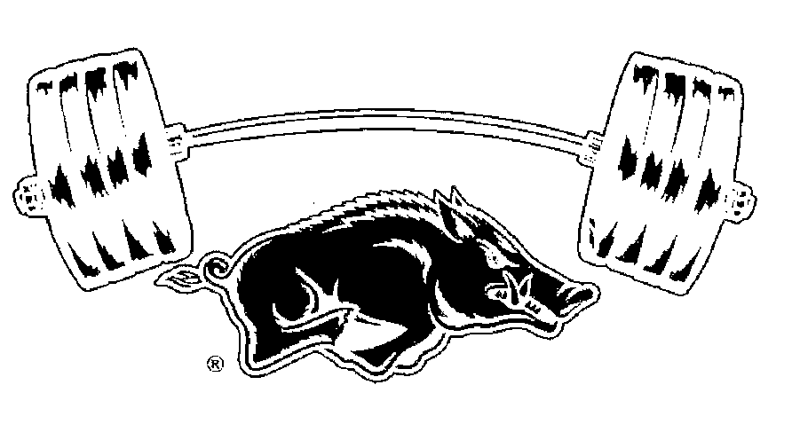
Head Strength and Conditioning Coach For Olympic Sports
University of Arkansas Department of Athletics
3-Phase Athlete Development Program. Email to get more information and to purchase a copy of our excel layout for your own 3-Phase Athletic Development Program for only $175.

IronHogPerformancecamp@gmail.com
tbarbour@uark.edu

IRON HOG 3-Phase Athletic Development Program
Phase #1 Rookies Program (Green Sheets)
Goals:
- Increase Work capacity
- Identify limitations:
- Movement Pattern Based:
  - High Volume & Low Variety in exercises
  - Focus on Foundation Exercises for YOUR program
  - Teach Teach Teach
- Program design, terminology, methodology, coaching cues
- Teach Recovery Methods
  - Simple nutrition facts
  - Soft tissue recovery methods
  - Hot & Cold water therapy
- Teaching these young student athletes how to Train outside their comfort zone. Making them very uncomfortable with both physical stress and mental stress.

Phase #2 Developmental Program (White Sheets)
1st – 3rd year athletes with a sound developed training background
Goals:
- Lower Relative Volume and Increased Variety in our exercises
- Solid at our Foundation Exercises
  - Good technique
  - Understands cues and feels the difference between a Good rep and a Bad rep
- Increase Strength and Explosive Power
  - Introduce Velocity Based Training (VBT)
  - TriPhasic Training methods
- Increase %LMM and decrease BF%
- Increase work capacity
- Continue to Learn and start to Lead
Phase #3 Advanced Program (Red Sheets)
Mature athletes 2nd – 5th year in our program and very mature training age.
Goals:
- Lowest Relative Volume and Increase Variety in all exercises
- Recovery
- Increase Power
  - VBT
- Increase Strength
- Increase %LMM
- LEAD

Your foundation of strength
More force you can apply to the ground the higher you will jump and faster you will run.
Match that with increased rate of force development, how fast you apply that force, you will jump higher and run faster.
Strength is the foundation of any successful program
1. Get Stronger
2. Increase rate of Force Development
3. improve jumping mechanics
4. improve flexibility
Dynamic Effort Days:
Squat x 2reps
Deadlift x 1reps
Press x 3reps
x 8 Sets
x 10 Sets
x 12 Sets
Rotate % from 50-55-60-65%
Max Effort Lift 72 hours after Dynamic effort lift
Repetitive Effort Days:
60% x 50reps
65% x 40reps
70% x 30reps
75% x 25reps
or
65-75% x 2-4 Sets of Max Reps
All reps done at working weight

Max Effort Days:
x 5RM 85-88%
x 4RM 88-92%
x 3RM 90-94%
x 2RM 95-98%
x 1RM 95-100+%

IronHogPerformancecamp@gmail.com
tbarbour@uark.edu

